Ex.no:8 | MINI PROJECT – HEALTHCARE DATA ANALYTICS

Domain and Problem Statement
Domain: Healthcare Data Analytics & Hospital Performance Analysis
Problem Statement:
Healthcare organizations generate large volumes of patient admission, treatment and billing data but often lack consolidated insight into which conditions and admission types drive cost, how long patients remain admitted, and where clinical outcomes deviate from expected patterns. This project addresses these challenges by transforming raw patient admission records into structured business intelligence using Microsoft SQL Server, Power BI and Tableau, enabling analysis of length of stay, billing distribution, admission-type composition, insurance coverage, age-group concentration and test-result outcomes to support data-driven hospital resource planning and cost management.
Dataset Description
Dataset Name: Healthcare Patient Admission Dataset
Granularity: Each row represents a single patient admission record.
Key Entities & Attributes:
- Patient Demographics: name, age, gender, blood_type, age_group
- Clinical Information: medical_condition, doctor, medication, test_results
- Admission Details: date_of_admission, discharge_date, admission_type, hospital, length_of_stay
- Financial Information: billing_amount, insurance_provider, Billing Band

Volume: The raw dataset contained 55,500 records across 15 attributes. After cleaning and transformation, the final dataset contains 54,966 records across 17 attributes.
Data Source:
Primary Source: Healthcare Patient Admission Dataset prepared for hospital performance, clinical outcome and treatment cost analysis.
Storage Infrastructure:
Cleaned and pre-processed patient admission records maintained in a CSV dataset and imported into Microsoft SQL Server under the database healthcareDB, and subsequently connected to Power BI and Tableau for interactive dashboard, drill-through and story development.
Architecture:
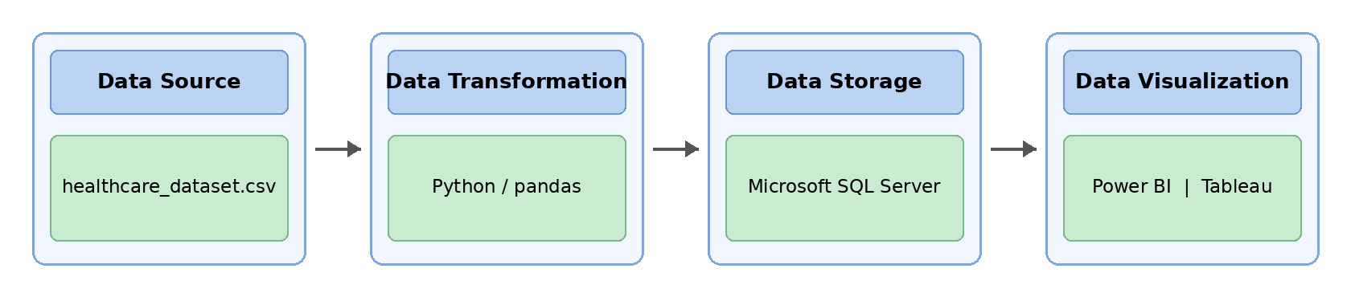
Program:
1. Python – Data Cleaning & Transformation
import pandas as pd

df = pd.read_csv("healthcare_dataset.csv")
health = df.copy()

for col in ["Medical Condition", "Admission Type", "Insurance Provider",
"Hospital", "Doctor", "Medication", "Test Results",
"Gender", "Blood Type"]:
health[col] = health[col].fillna("Unknown")

health["Billing Amount"] = health["Billing Amount"].fillna(0).abs().round(2)

health["Date of Admission"] = pd.to_datetime(health["Date of Admission"], errors="coerce")
health["Discharge Date"] = pd.to_datetime(health["Discharge Date"], errors="coerce")

health["Length of Stay"] = (health["Discharge Date"] - health["Date of Admission"]).dt.days
health = health[health["Length of Stay"] >= 0]

def age_band(a):
if a <= 18: return "0-18"
elif a <= 40: return "19-40"
elif a <= 60: return "41-60"
else: return "60+"

health["Age Group"] = health["Age"].apply(age_band)

health.drop_duplicates(inplace=True)
health.columns = (health.columns
.str.lower()
.str.strip()
.str.replace(" ", "_"))

print("Original Shape:", df.shape)
print("Cleaned Shape:", health.shape)
print("\nDataset Preview:")
print(health.head())
print("\nDataset Information:")
print(health.info())

health.to_csv("healthcare_clean.csv", index=False)

Output:
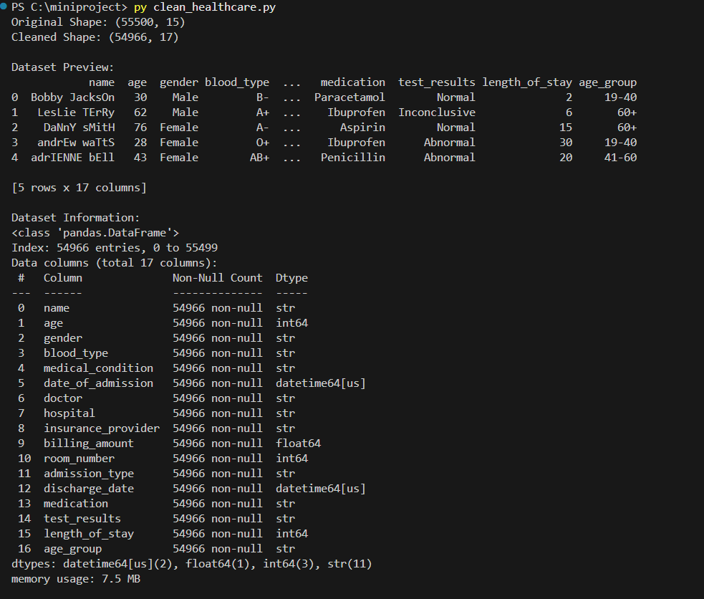
2. SQL SERVER CONNECTIVITY
INSTALL SQL SERVER MANAGEMENT STUDIO
1) Install Microsoft SQL Server and connect through SSMS
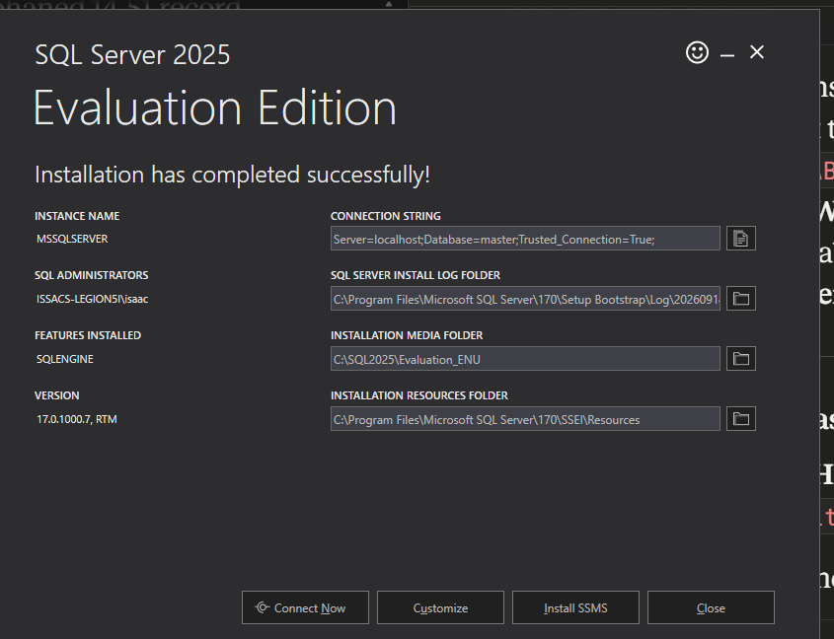
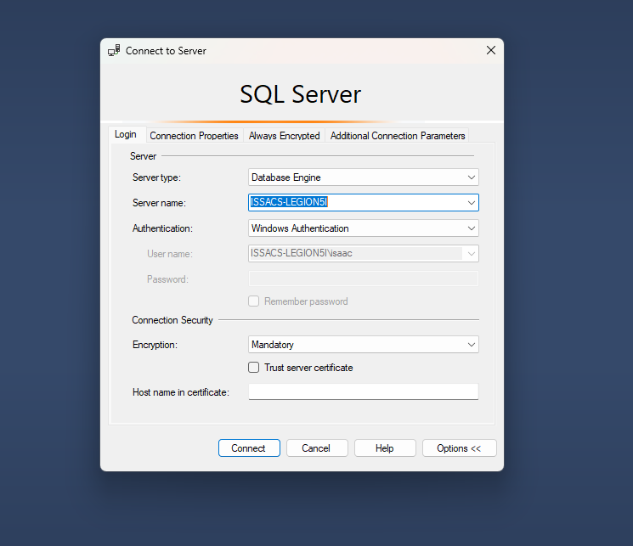
2) Create database named “healthcareDB”
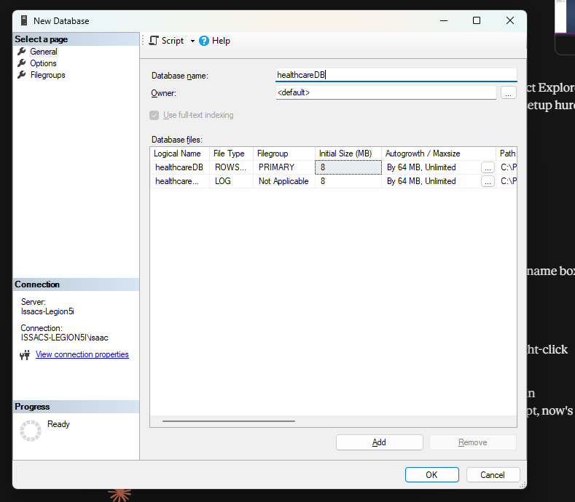
3) Import the csv file of the dataset
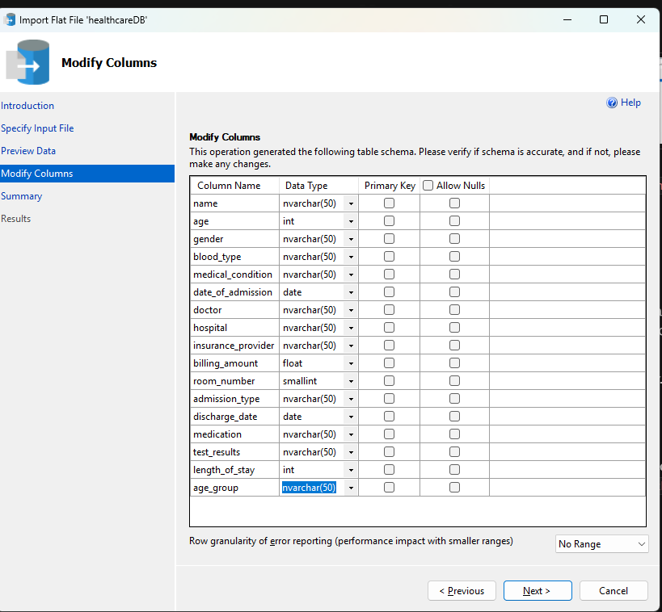
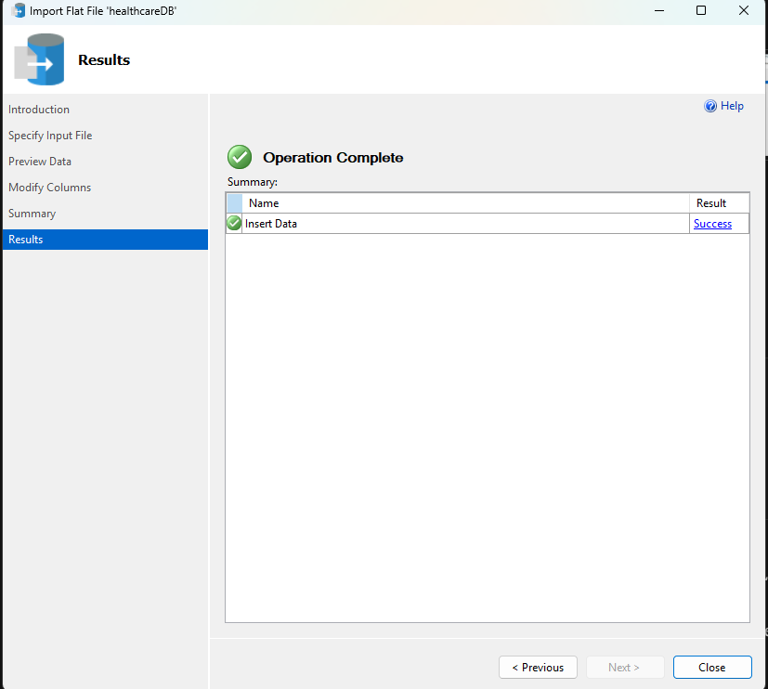
4) Verify the imported records
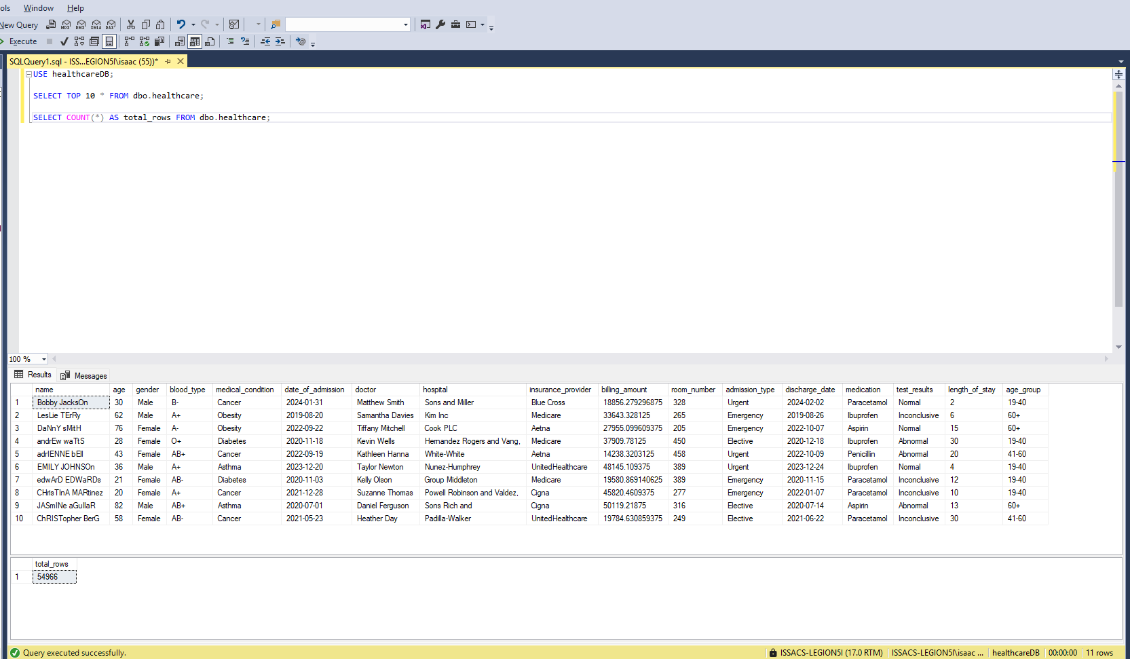
POWER BI
5) Connect Power BI to SQL Server
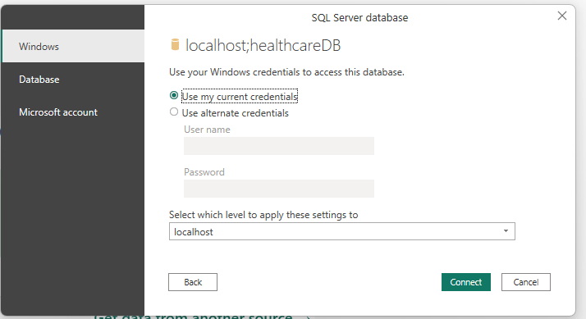
6) Transform data in Power Query
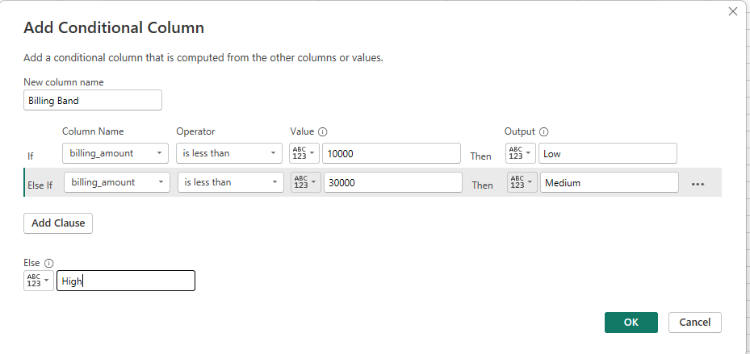
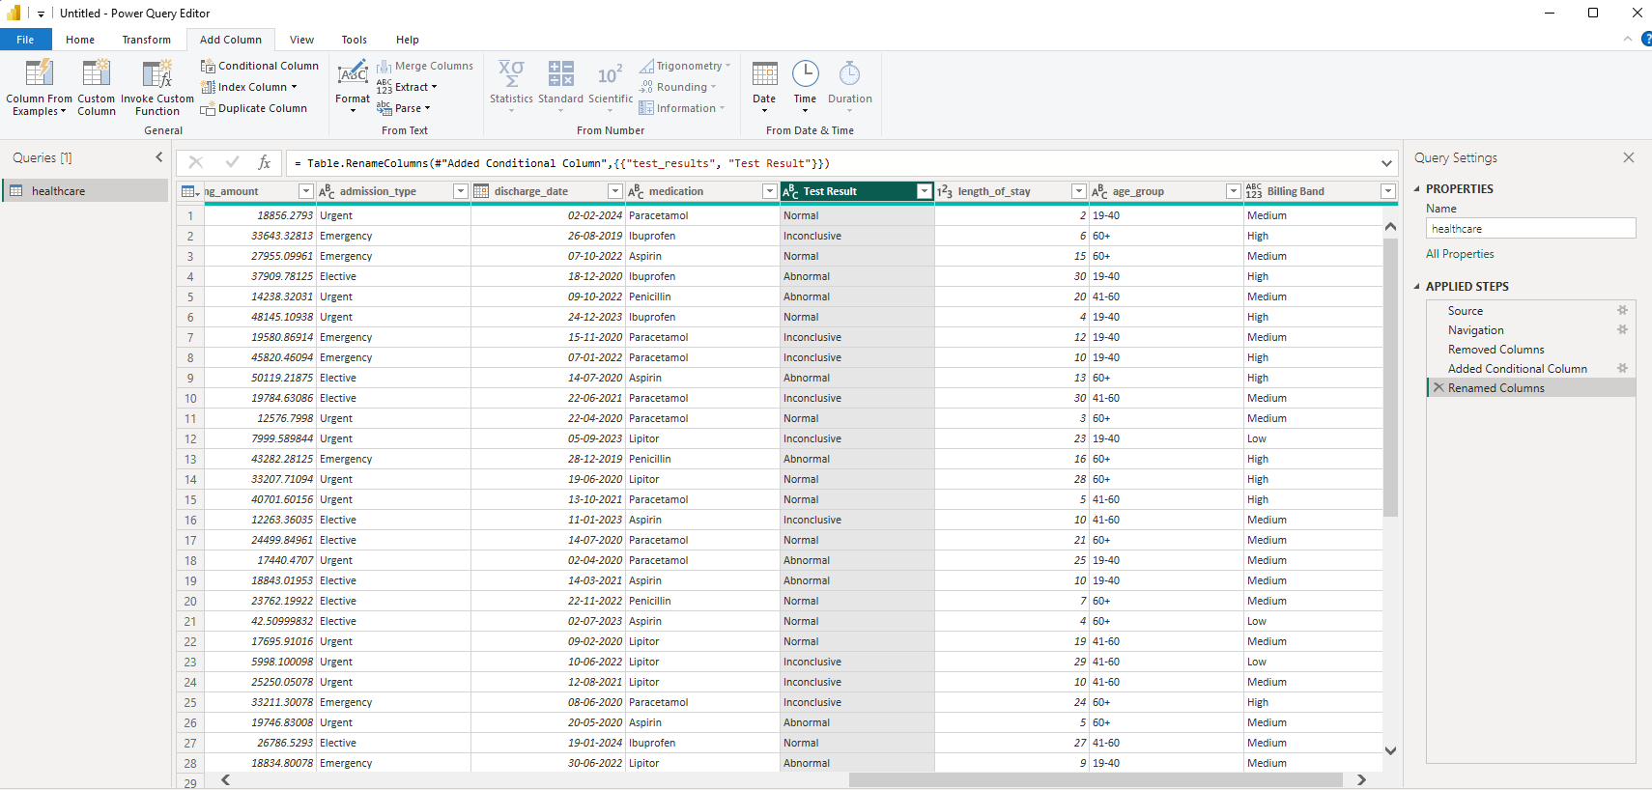
7) Create the DimDate calendar table
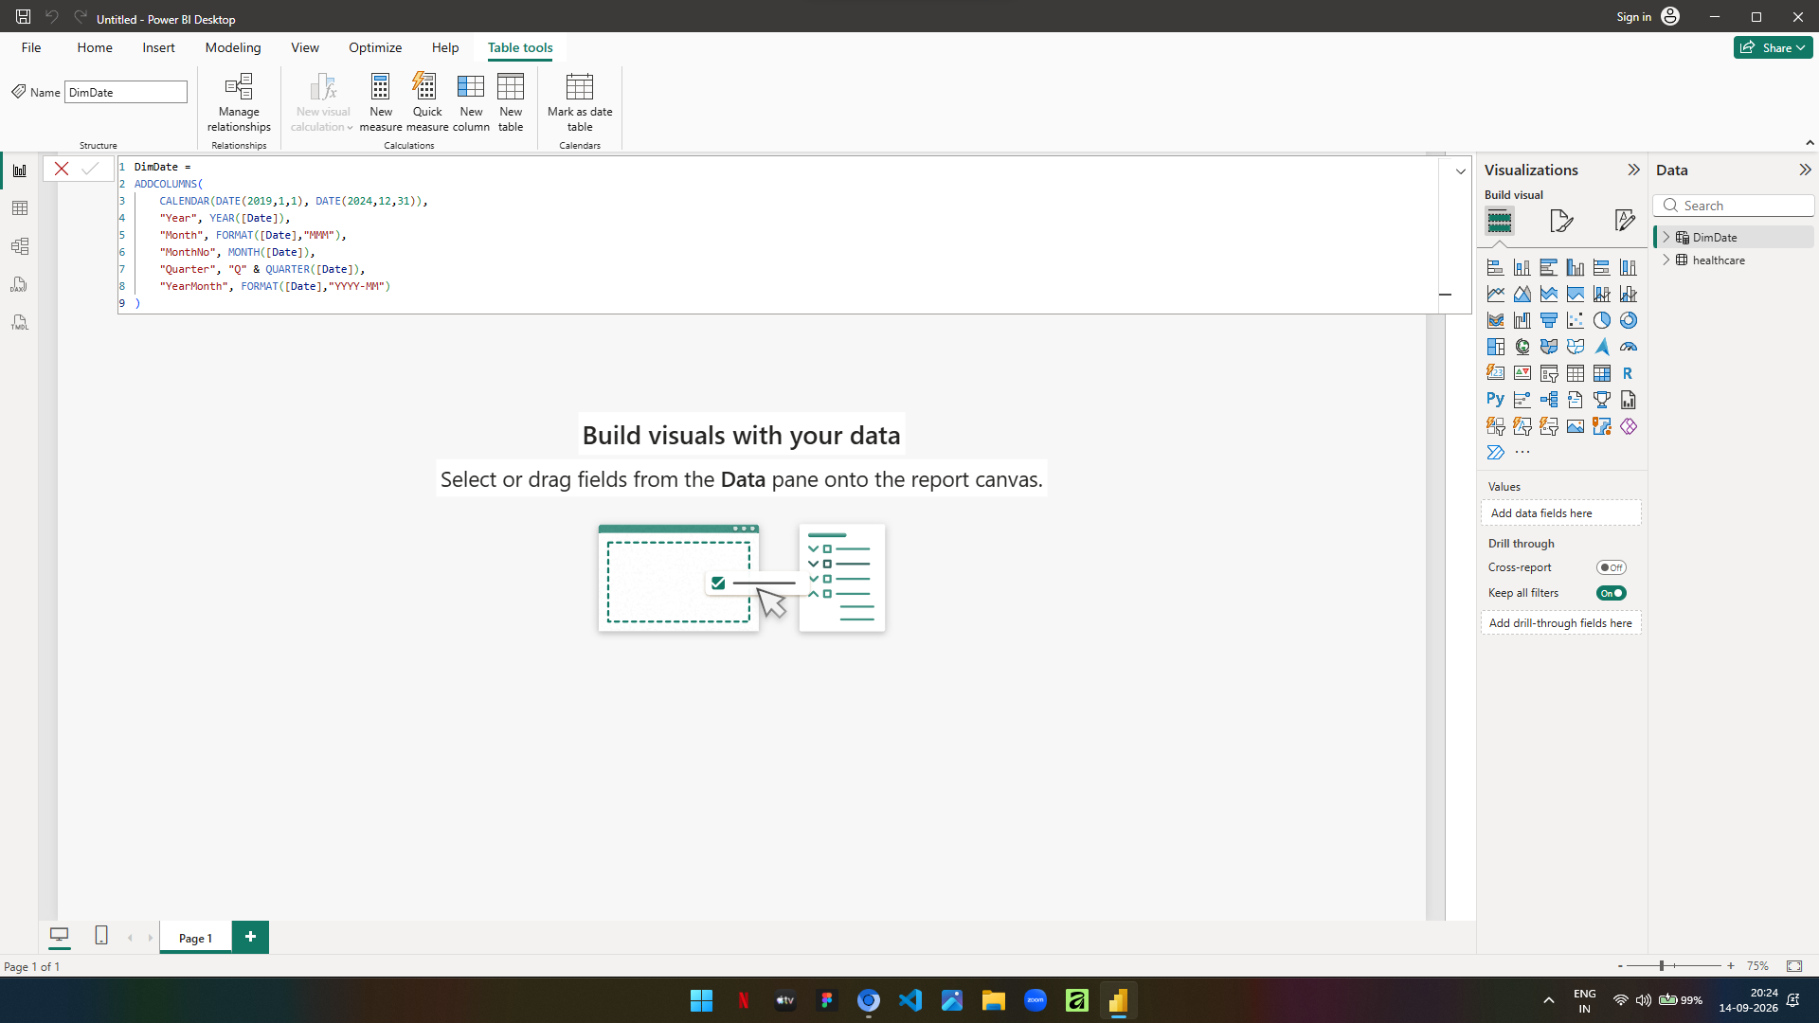
8) Build the relationship and data model
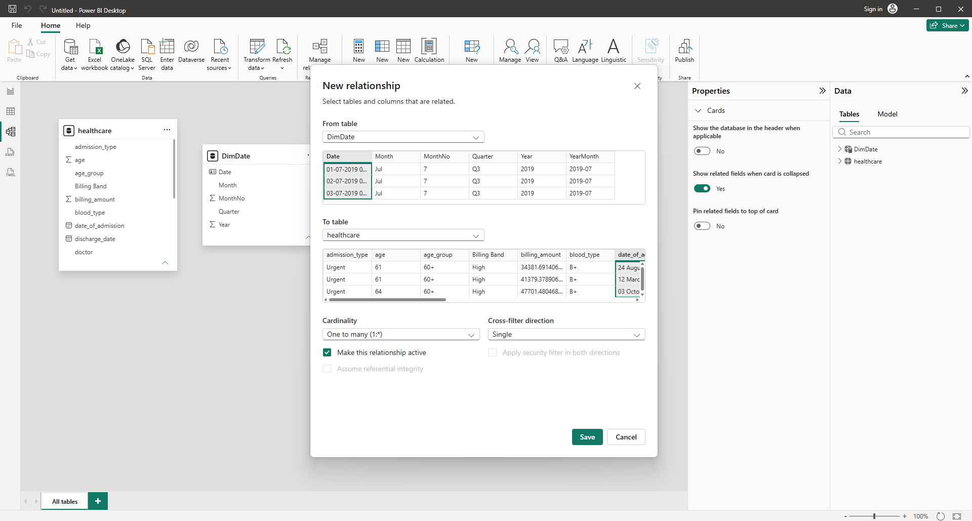
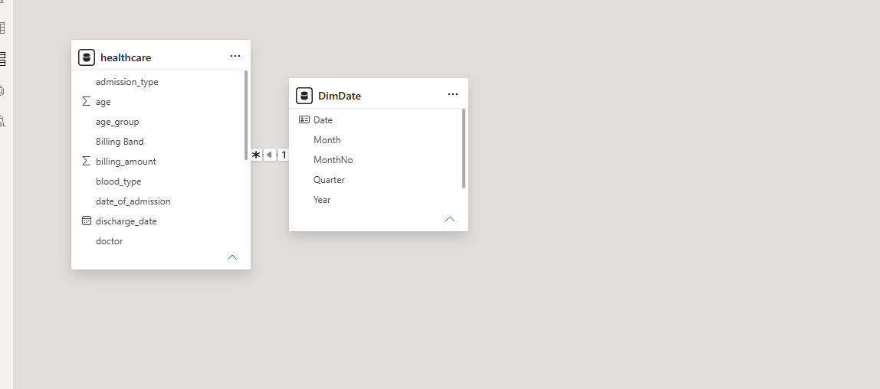
9) Create DAX measures
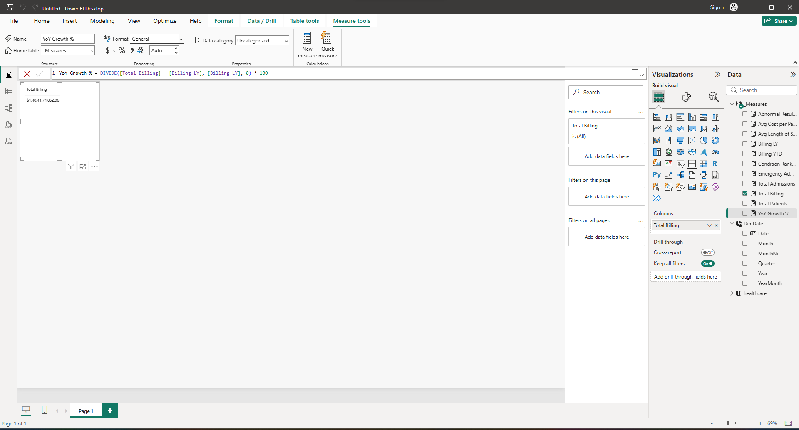
10) Create calculated column – Stay Category
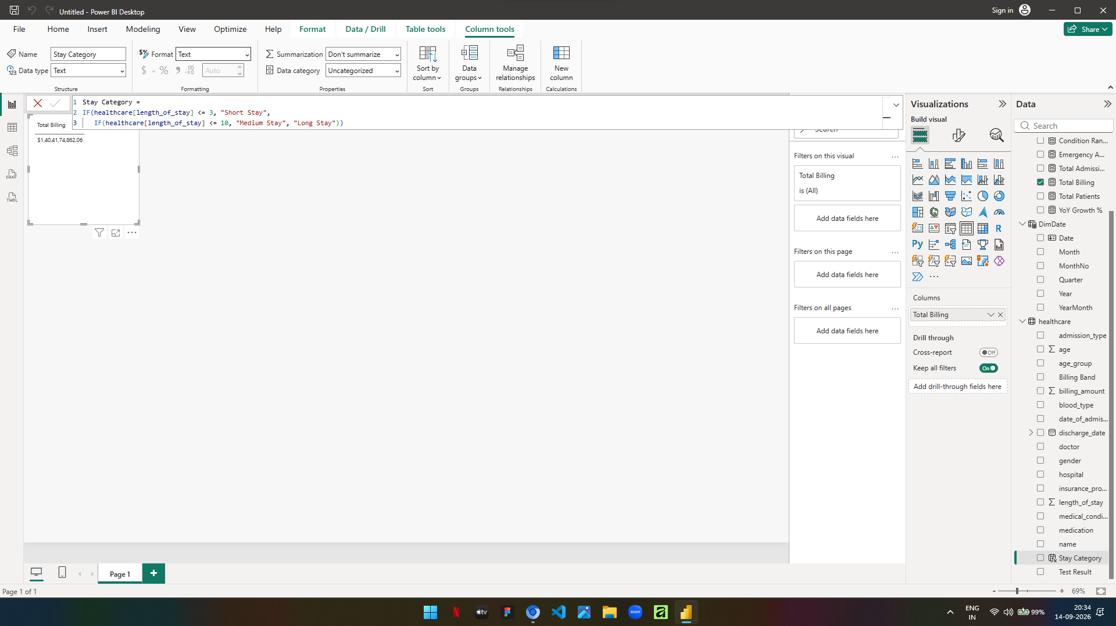
11) Executive canvas – place card visuals across the top
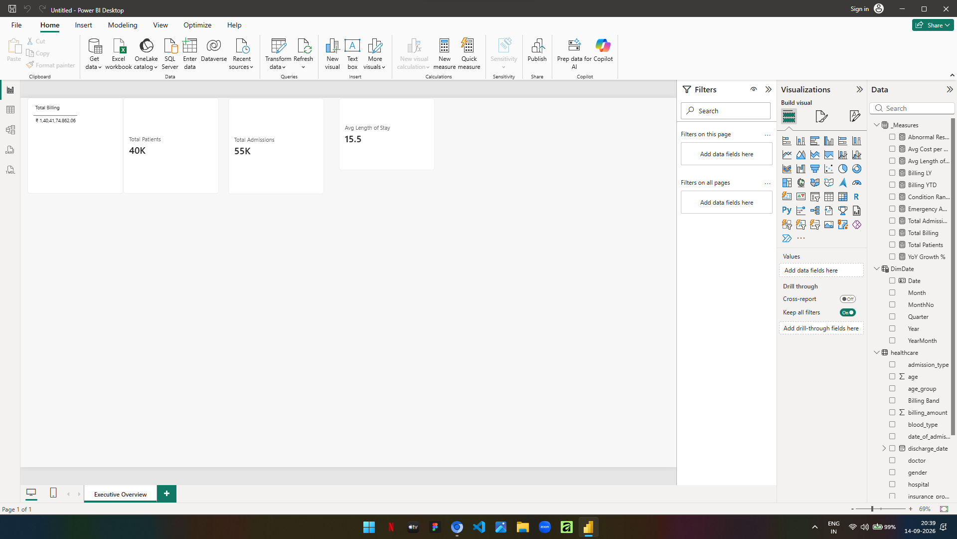
12) Visualise billing trend with drill-down hierarchy
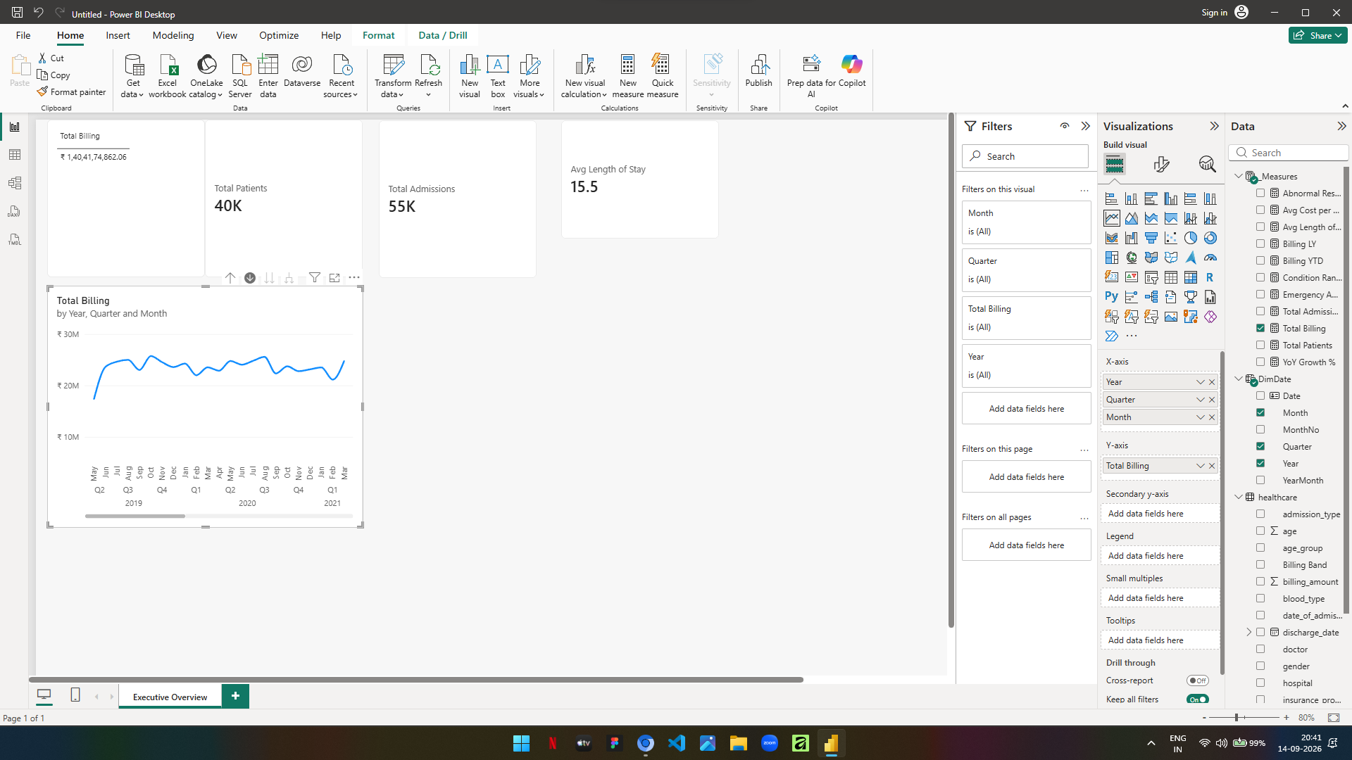
13) Visualise patient count by medical condition and admissions by type
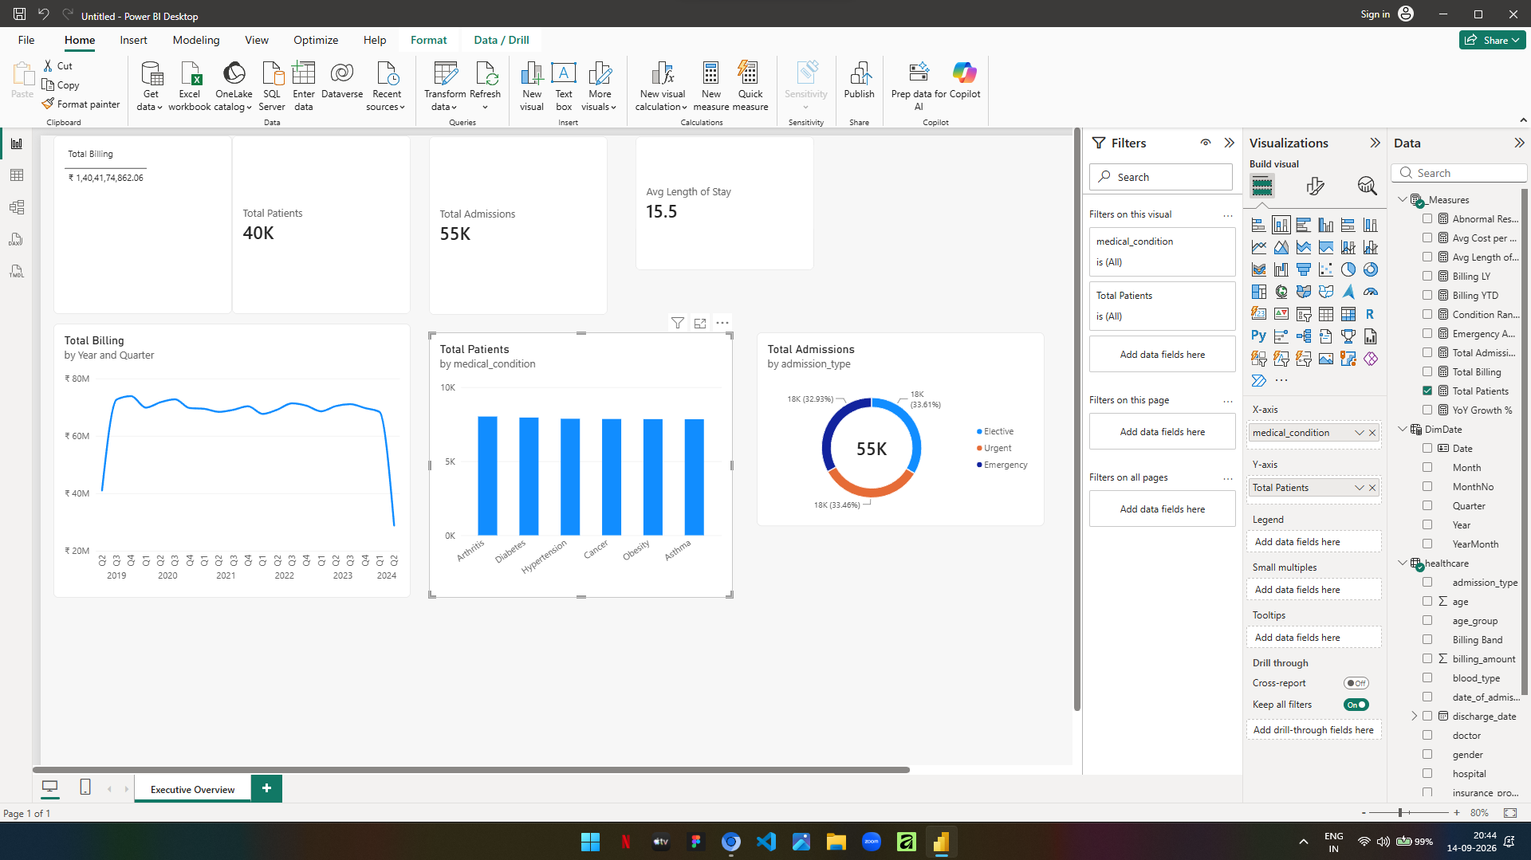
14) Matrix with conditional formatting
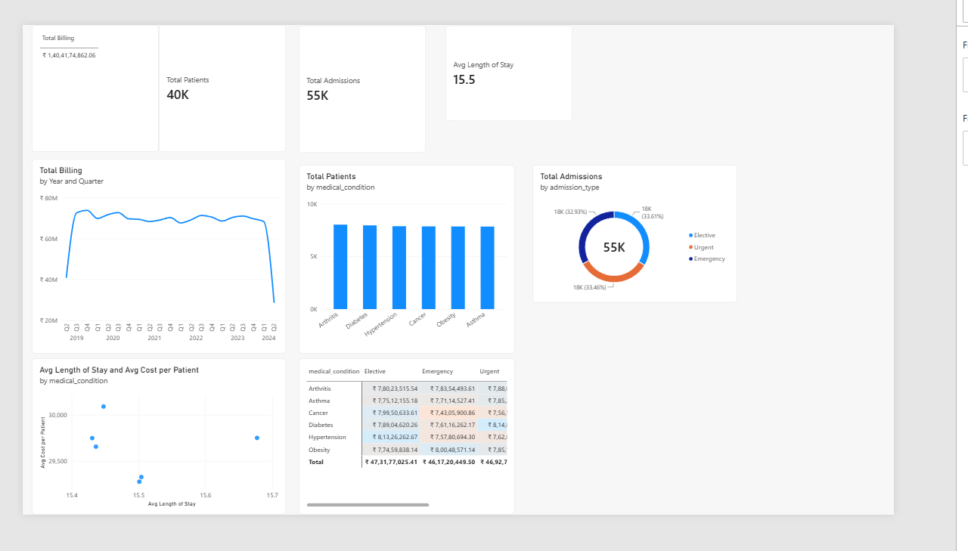
15) Create slicers by medical condition, insurance provider and date
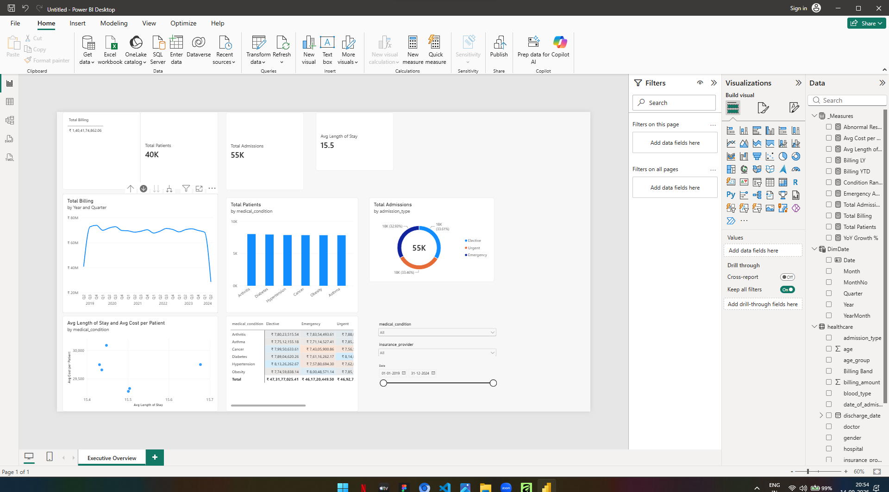
16) Decomposition tree and key influencers
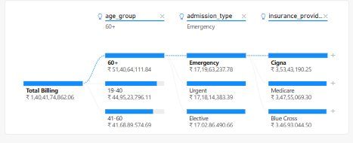
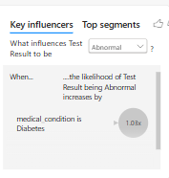
17) Power BI Final Executive Dashboard
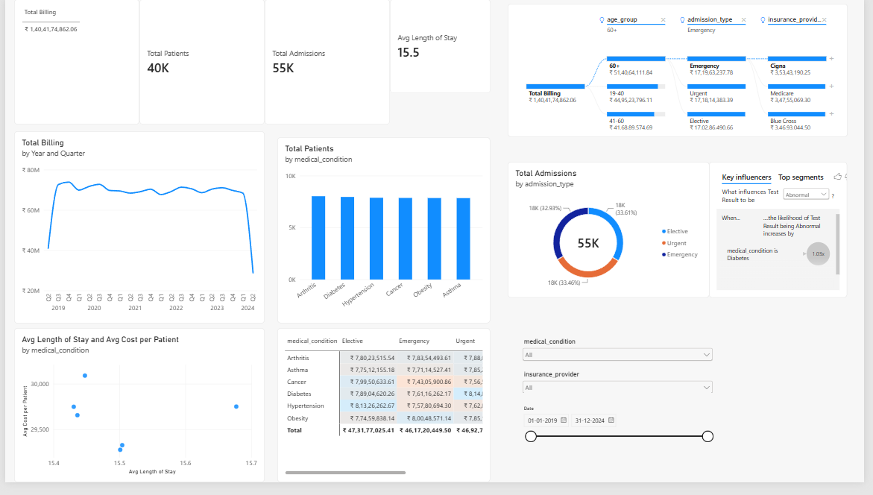
18) Implement drill-through to patient detail page
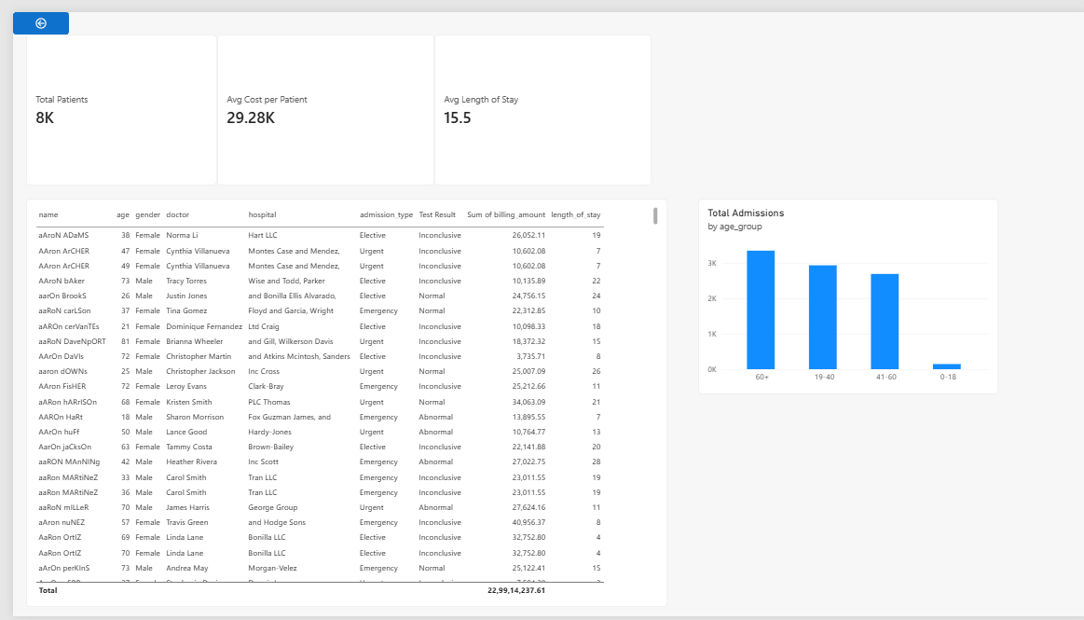
19) Bookmarks and navigation buttons
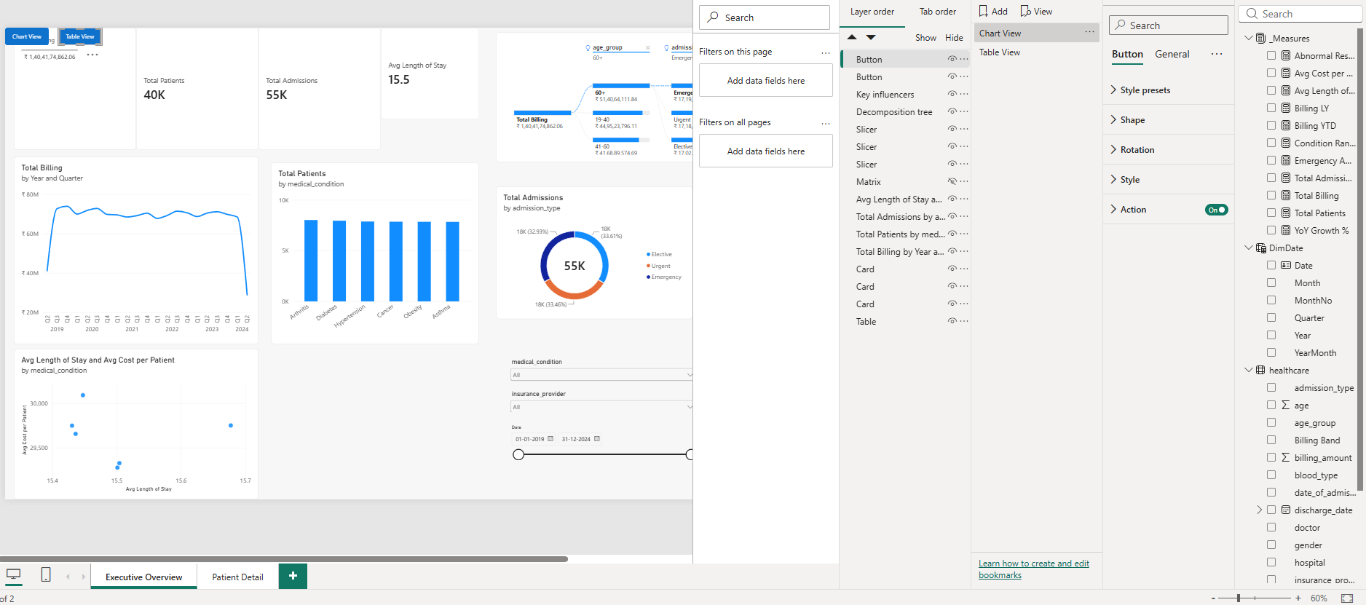
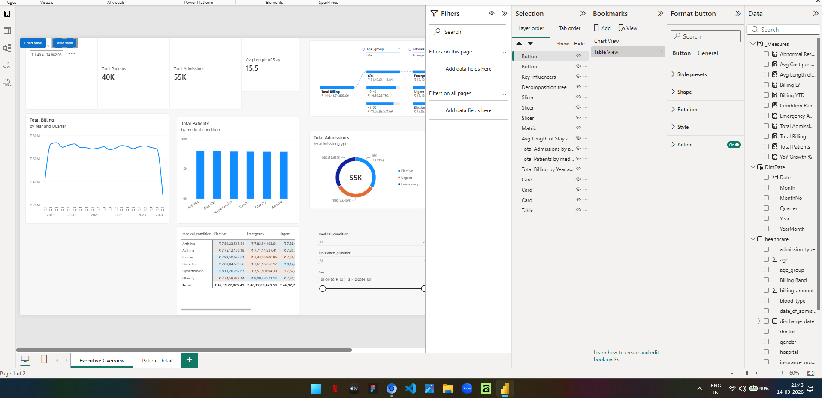
TABLEAU
20) Import the data from SQL Server
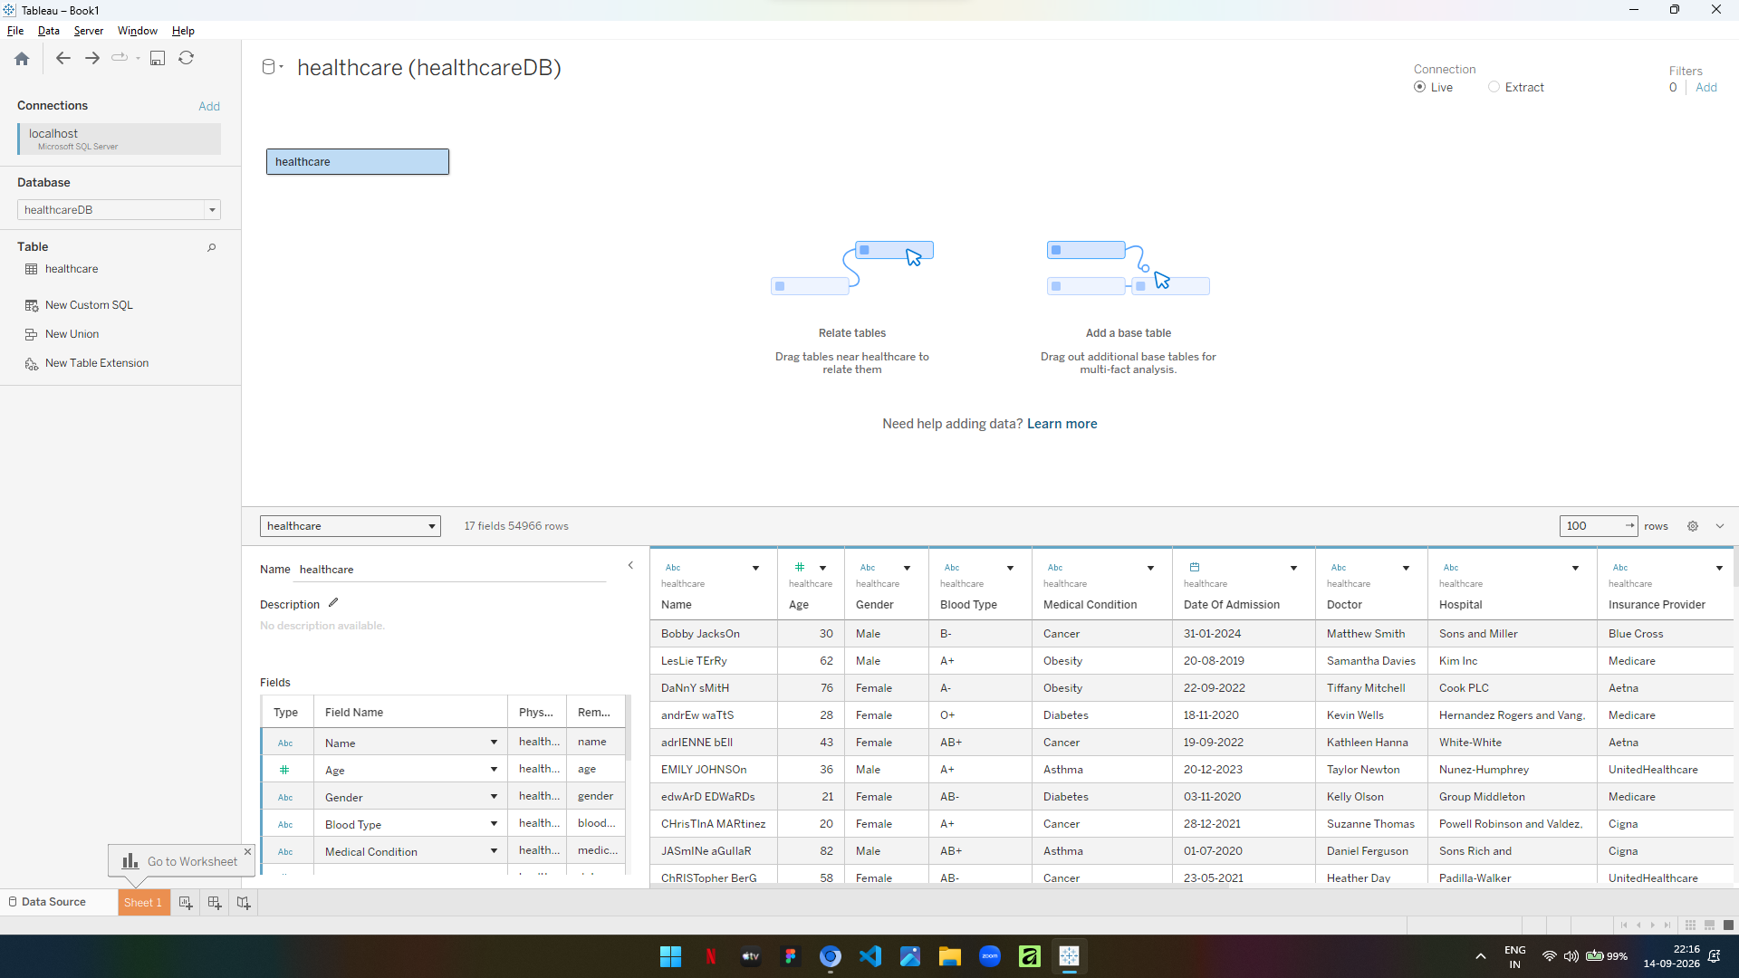
21) Build calculated fields
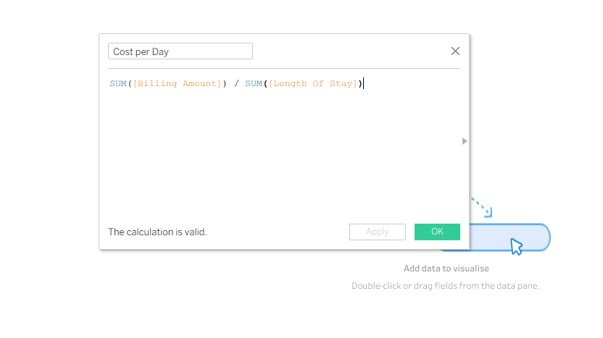
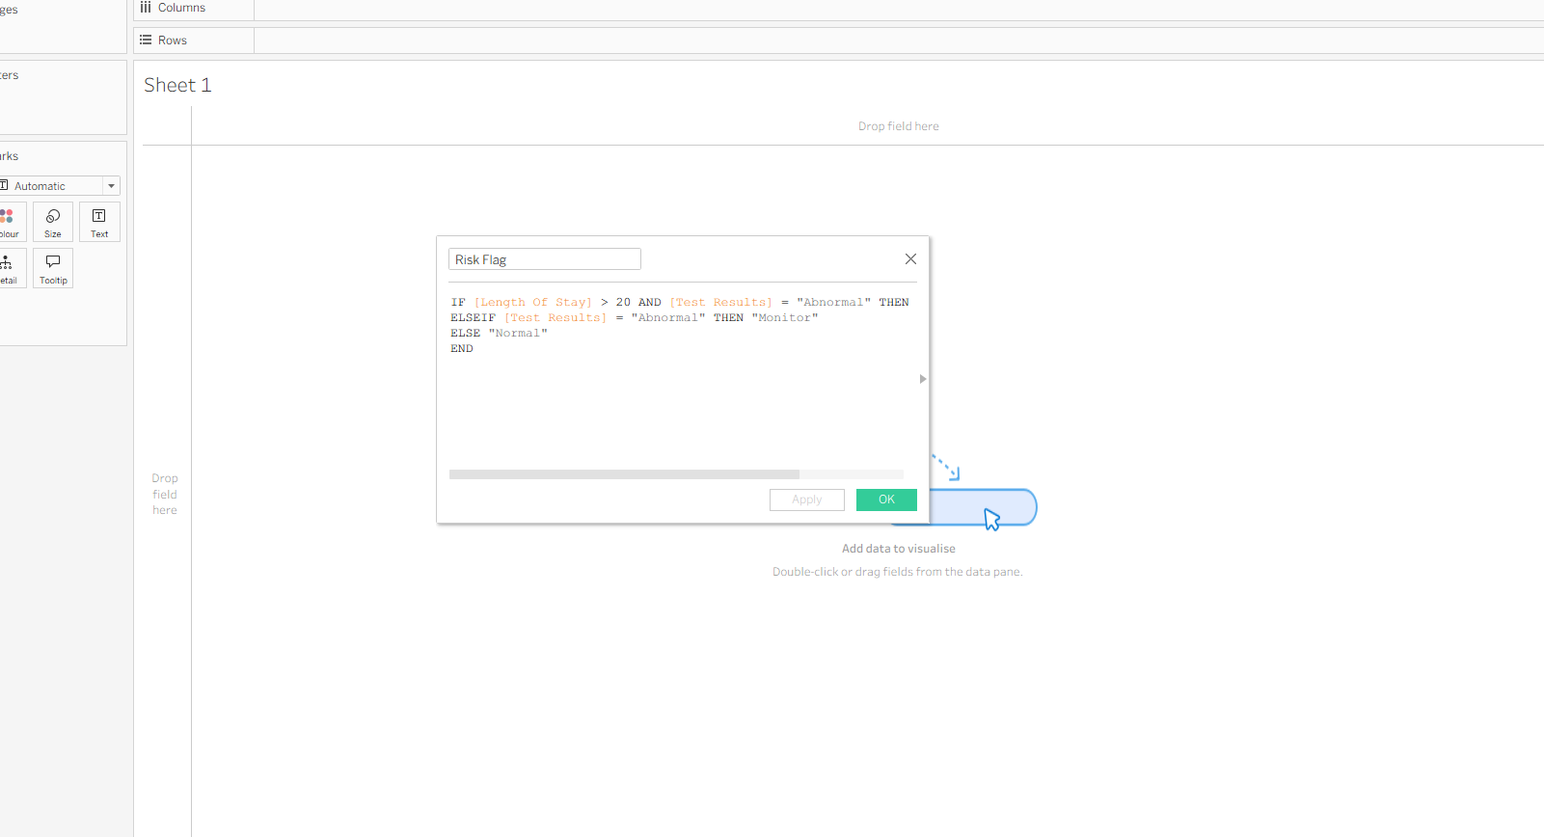
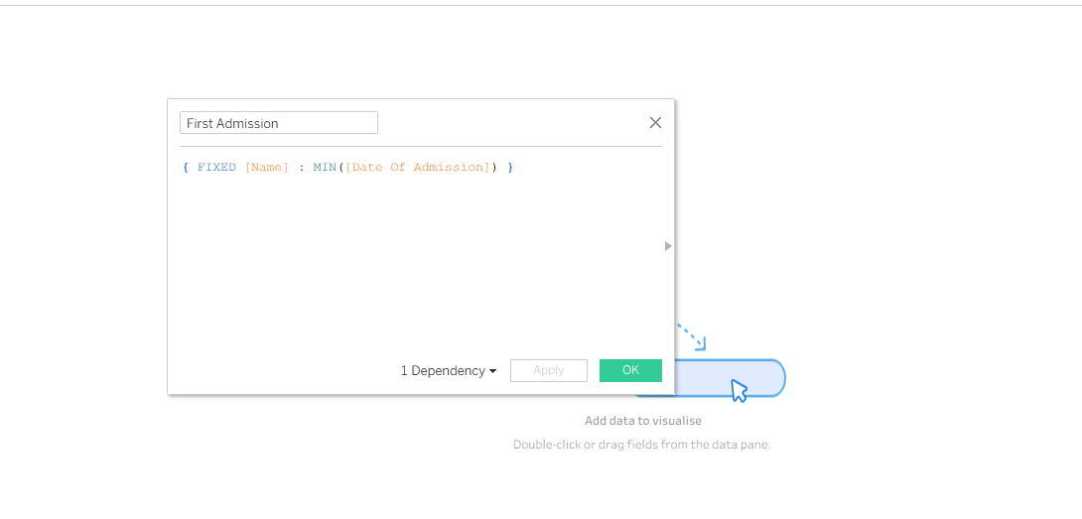
22) Build parameters
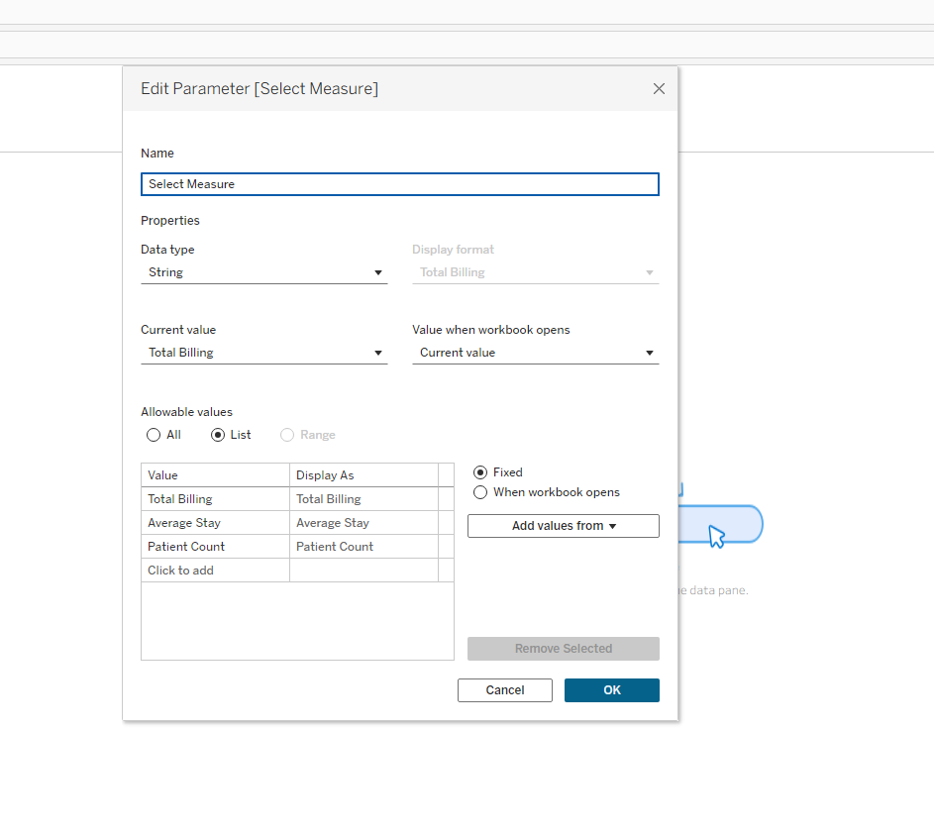
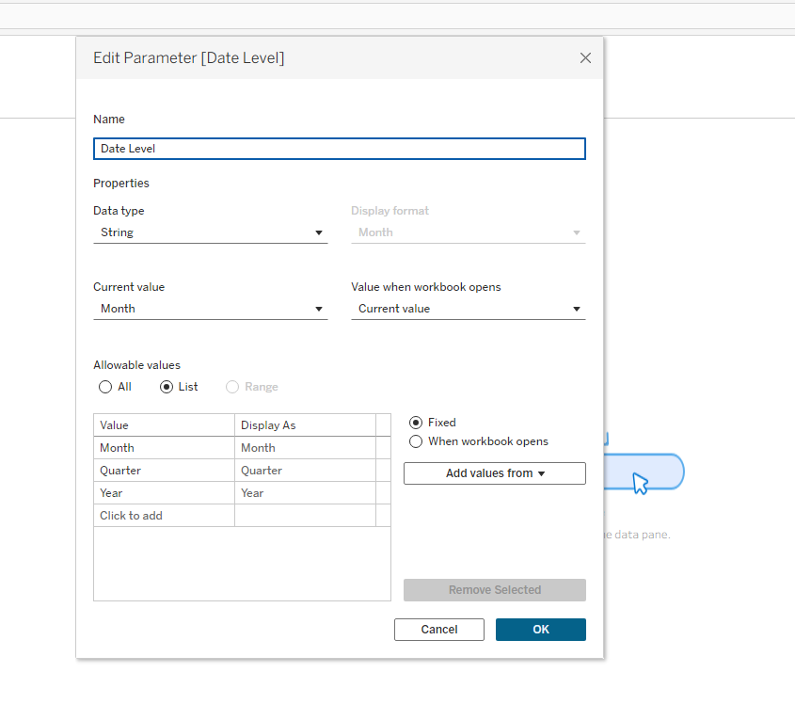
23) To visualise top conditions by billing
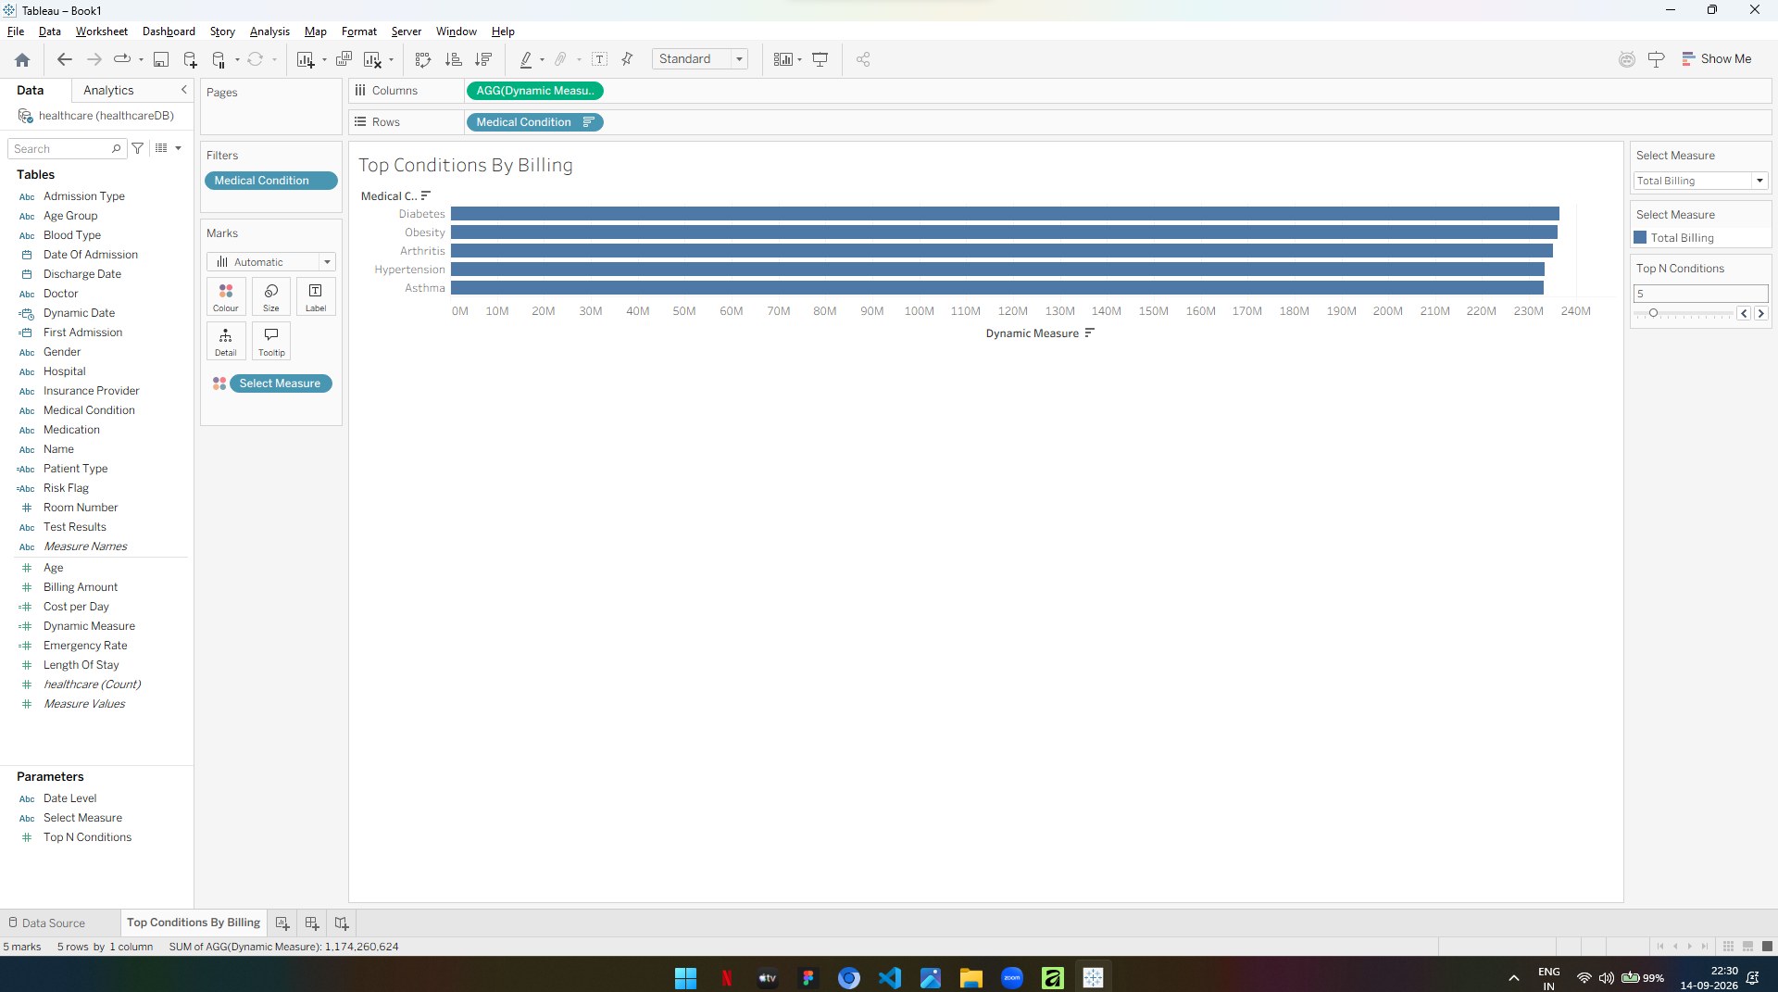
24) To visualise billing trend over time
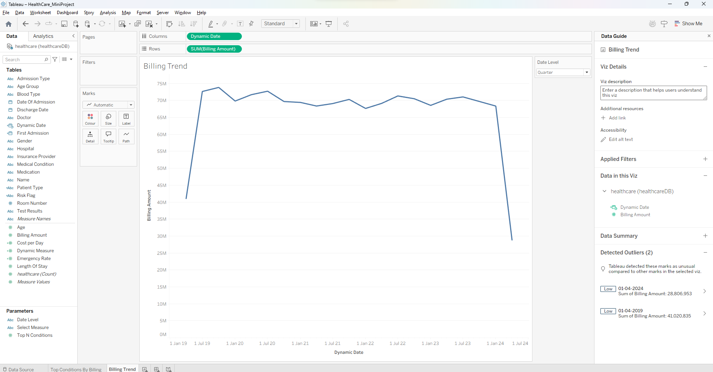
25) To visualise average stay against billing by admission type
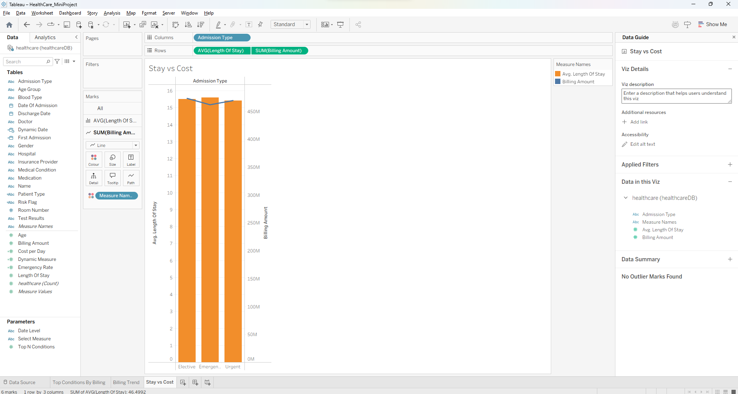
26) To visualise condition against age group
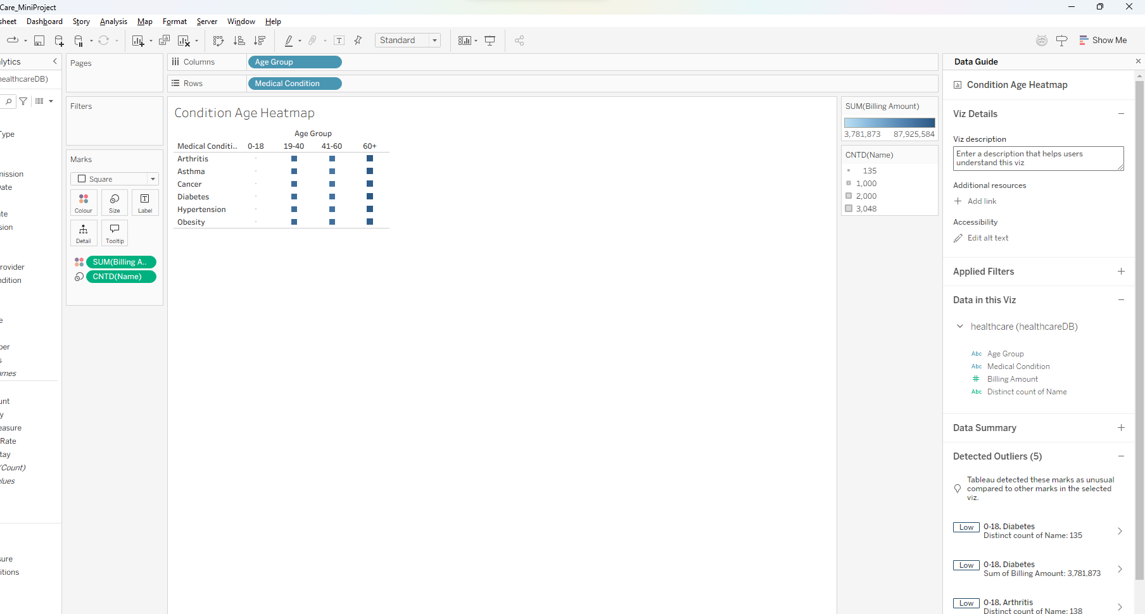
27) To visualise billing distribution by insurance provider
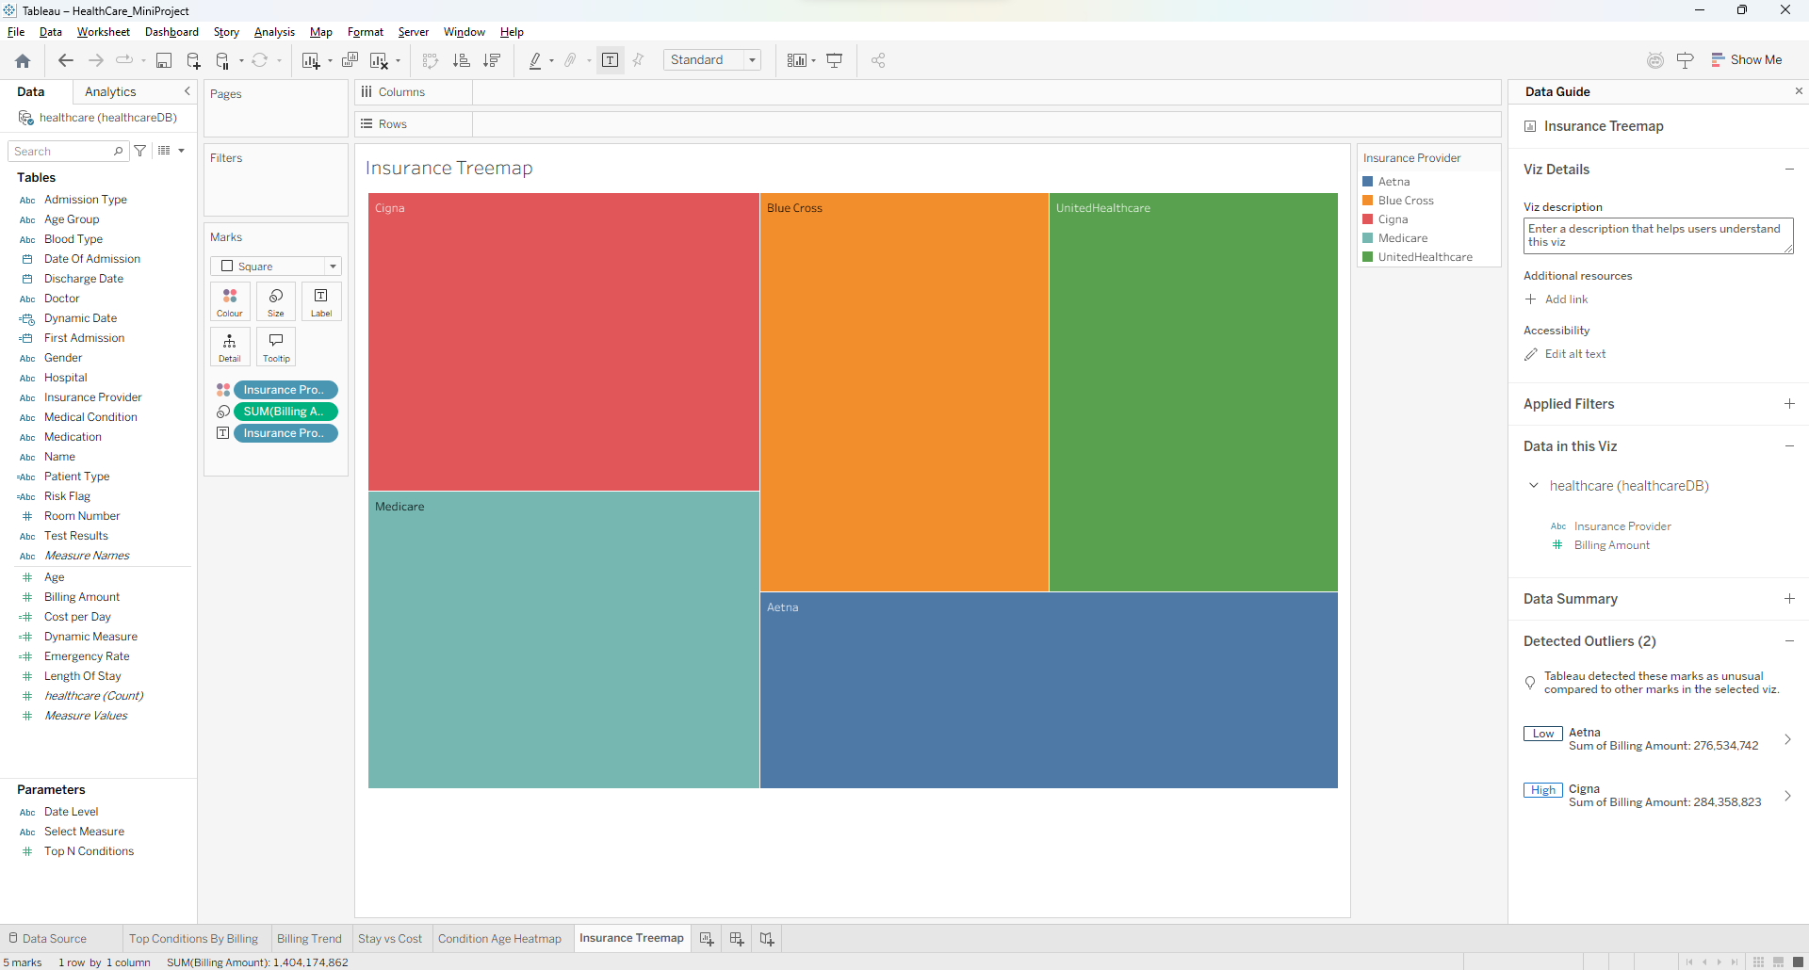
28) To visualise risk classification by patient type
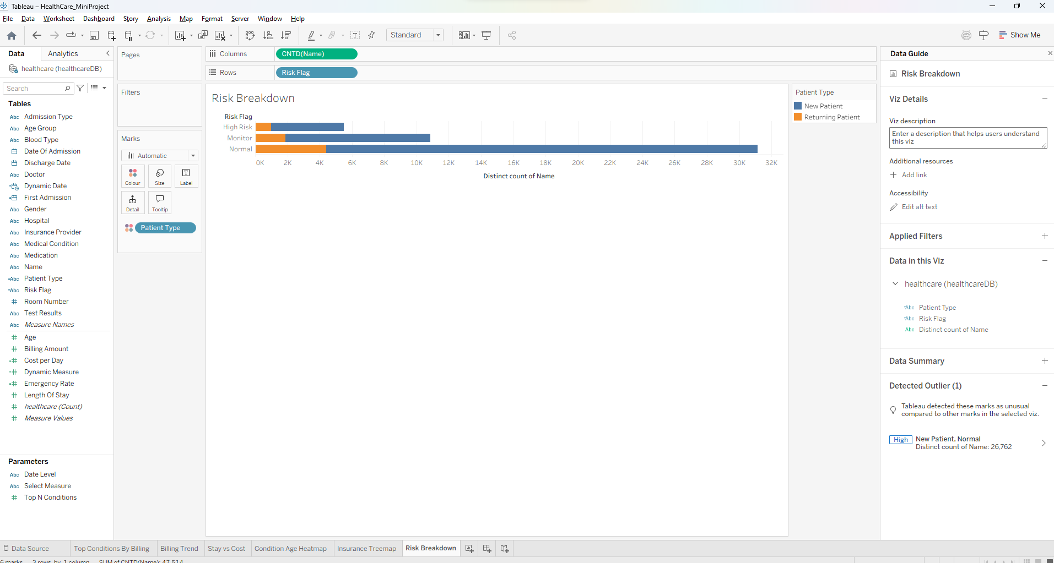
29) FINAL DASHBOARD
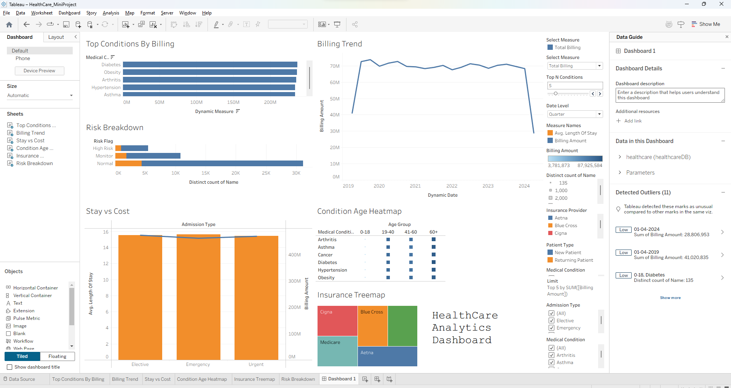
30) Dashboard actions
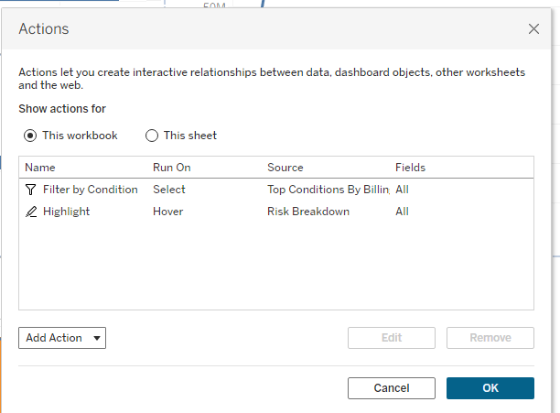
31) Build the analytics story
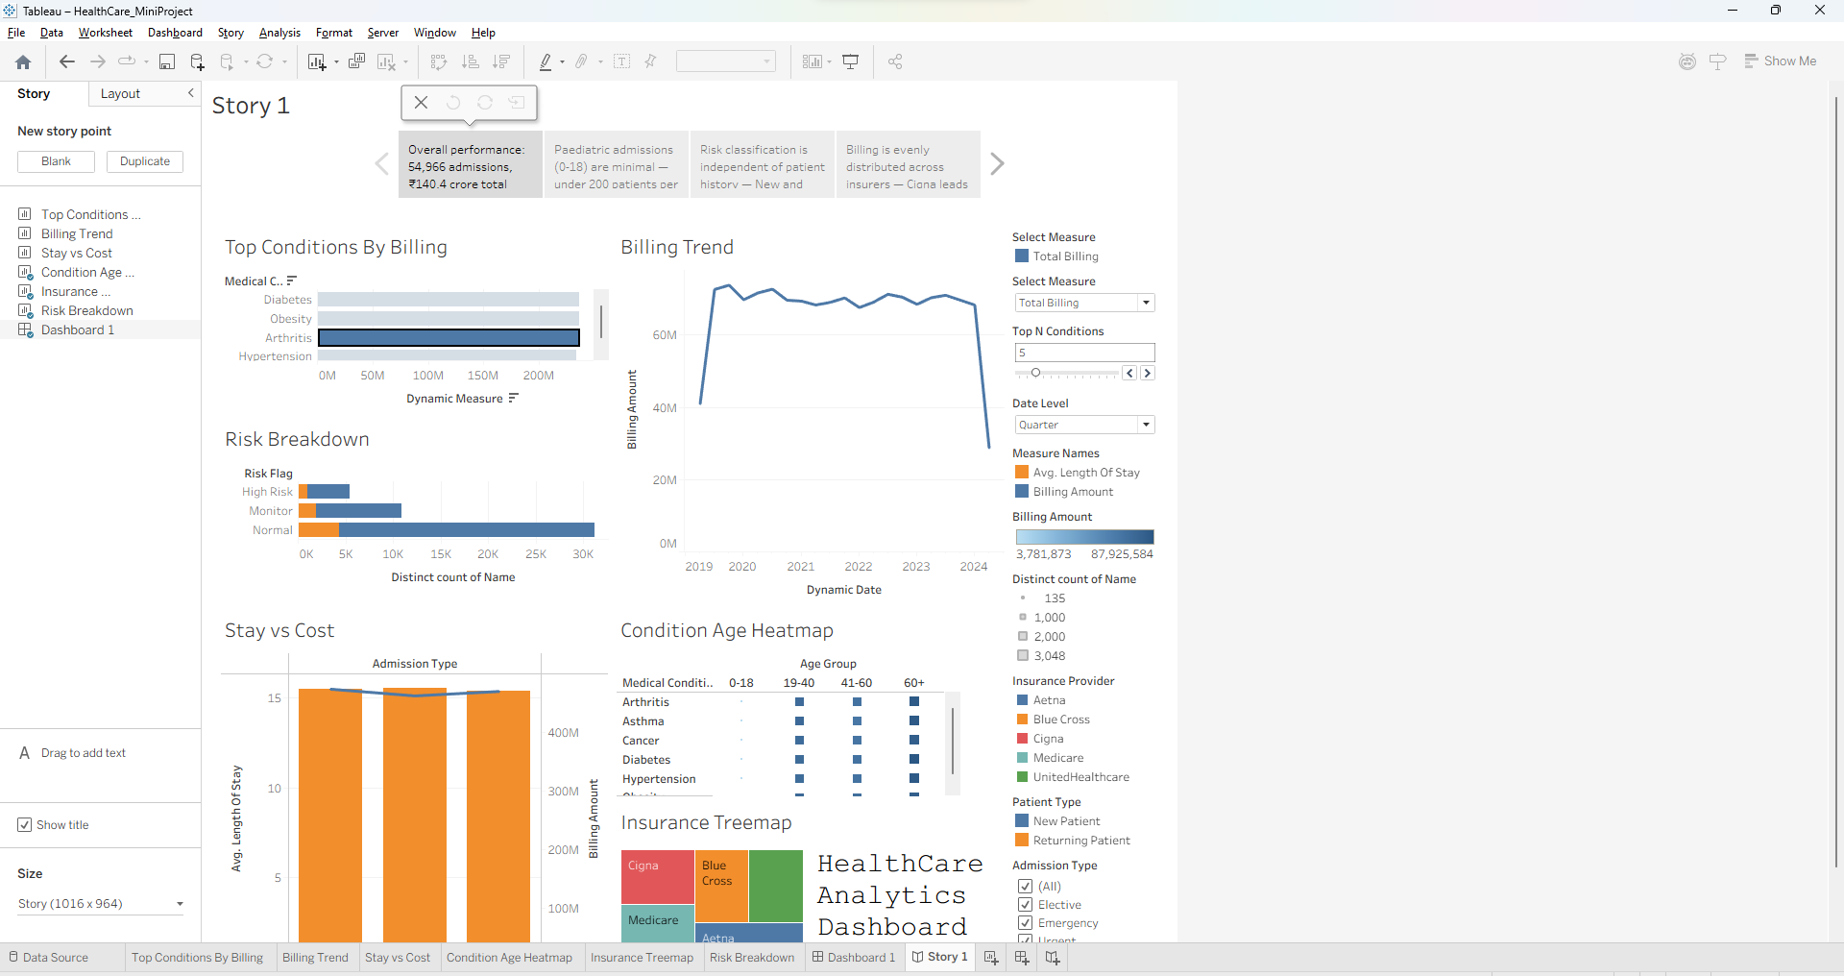
Observed Insights
1. Age Group Concentration
Patients aged 60 and above account for the single largest share of total billing, contributing approximately ₹51.40 crore of the ₹140.42 crore recorded across the dataset, which is close to 37 percent of overall revenue. The 19-40 and 41-60 bands follow at roughly ₹44.95 crore and ₹41.69 crore respectively. Paediatric admissions in the 0-18 band are almost negligible, recording fewer than 200 distinct patients per medical condition against approximately 3,000 in every other age band.
2. Admission Type Distribution
Admissions are distributed almost evenly across the three admission pathways, with Elective at 33.61 percent, Emergency at 33.46 percent and Urgent at 32.93 percent of the 54,966 total admissions. The average length of stay remains stable between 15.4 and 15.6 days irrespective of admission type. This indicates that admission urgency is not a determinant of hospital stay duration within this dataset.
3. Billing and Condition Patterns
Total billing across the period amounts to ₹1,40,41,74,862.06, with an average cost per patient of approximately ₹34,900. Diabetes records the highest total billing among all medical conditions, followed by Obesity and Arthritis, though the spread between the highest and lowest condition is narrow. Drill-through analysis on an individual condition reduces the average cost per patient to approximately ₹29,280, roughly 16 percent below the overall average.
4. Insurance and Risk Classification
Billing is spread evenly across the five insurance providers, with Cigna leading at ₹28.43 crore and Aetna lowest at ₹27.65 crore, a difference of only 2.8 percent. Risk classification derived from length of stay and test outcome places approximately 32,000 patients in the Normal band, 11,000 under Monitor and 6,000 as High Risk. The proportion of new to returning patients remains consistent across all three risk tiers, indicating that risk level is independent of prior admission history. Key influencer analysis further confirmed no meaningful predictor of abnormal test results, with the strongest factor raising likelihood by only 1.03 times.

